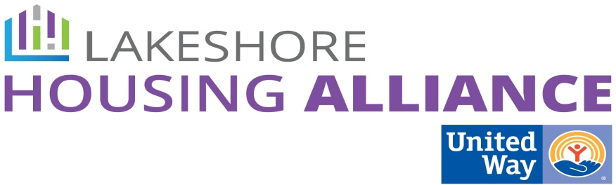****

**Private/Non-Profit Partnership**

**Business Leader Education Project**

**Agenda**

1. Introductions and reviews

* Mutually reinforcing activities

2. What are the parameters that define the top 15 companies?

* Possible parameters
  + Retention rates
  + Where are you based on infrastructure GIS Map?
    - Bus lines
    - Walk scores
    - Carpooling
  + Already “Lives United” (different messages for those not involved)
    - Heavily engaged in the community
  + Size: # of employees
  + Income threshold (below the ALICE threshold): 50 employees
  + Pre-existing employee assistance program in company
  + Family vs corporate owned

Higher weight to the ones highlighted

* How do we find the data?
  + Lakeshore Advantage, MI Works
  + LHARMA
  + Live United companies

3. What do we want them to know and then do…?

* Stable housing improves…
* Share the ALICE data/story
* Make sure to make the connection with other OHN strategies
* Business Case:
  + Would you like to be part of a pilot to study retention?

4. Parking Lot

* HR Survey
* Commuter rates (from outside the county)
* GIS Map
* Retention
* More info:
  + Melissa Dyke – DHS – dykem@michigan.gov
    - Corporate Liaison
  + MI Works
  + Lakeshore Advantage
  + Employer Resource Network
* Small group or one-on-one?
* Anecdotes of local successes and failures

4. Goal:

* Create a table with the parameters.
* Agenda for business meeting
* Local anecdotal case studies