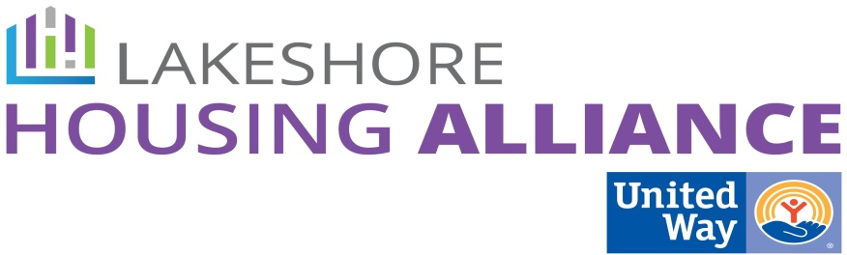****

**Tax Credits**

August 12, 9 AM

United Way

115 Clover

Holland

Minutes

**Present:** Chris Bennett, Steve Grose, Stacy Pacanowski, Shirley Reenders, Sue Harder, Marge DeBlaay, Lyn Raymond, Patrick Moran

1. Welcome and Introductions
2. Update: GIS Mapping

* Lyn reported that the GIS department has begin to gather the missing data points for the different map layers. The Inclusionary Zoning Work Group will continue to facilitate this process.
* Shirley suggested adding wetlands areas and flood plains to the map.

1. Create agenda for the meeting with municipalities

* What do we want municipalities to know?
  + The “why.” What affordable housing is needed in their municipality?
  + The “who.” Who needs affordable housing?
  + What does lack of affordable housing mean? Lower discretionary spending, for example.
  + Who supports the case for more affordable housing?
  + Default Future vs Preferred Future
  + Who we are?
  + What are the municipalities concerns about affordable housing?
* What do we want them to do?
  + Provide appropriate zoning for a tax credit project
  + Site plan approval, PILOT and all other requirements
  + Be supportive
    - Letters of support, advocacy
* Logistics
  + Who would go?
    - Work Group members especially developers
    - Business owners in the particular municipality
    - Big taxpayers
    - Representative of the ALICE demographic perhaps someone from the designated employer or municipality.
  + How to prioritize
    - GIS Map will indicate where
    - Census
  + Timeline
    - Maybe meet with developers first and share what we found.

1. Create agenda for community conversation of developers advocating for the target population.

* Educate the developers on the issue.
* What is your experience with affordable housing projects?
* What are the barriers to doing affordable housing?
* What can we do to remove the barriers?
* Ideation – What might we do?

1. Next Steps

* Chris will map out LIHTC process
* Lyn will gather LIHTC projects due to expire in the next ten years.
* How many mission based developers are there?
* Create a network of landlords, organizations and developers to communicate about available programs, etc. (Private/Non-Profit Partnerships and Lakeshore Housing Alliance)

1. Next meeting

* Wait until map is complete.