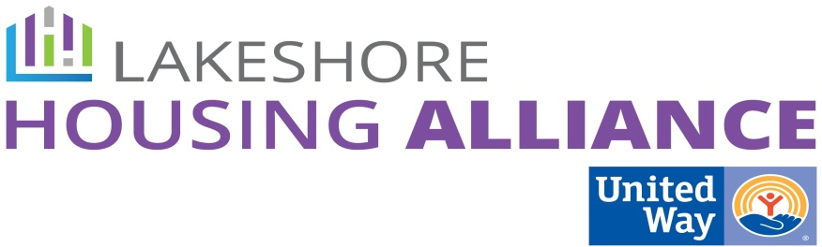****

**Tax Credits**

June 5, 9 AM

United Way

115 Clover

Holland

**Minutes**

Present: Patrick Moran, Liz DeLaLuz, Josh Ghena, Stacy Pacanowski, Marge DeBlaay, Steve Grose, Shirley Woodruff, Lyn Raymond

1. Welcome and Introductions

2. What is Collective Impact?

Lyn and Patrick reviewed progress to date. Work groups are currently creating mutually reinforcing activities

3. Work Group Expectations

Liz explained the work group expectations of 6 meetings over the course of 12 months; two to identify strategies, two to prioritize and 2 to create an action plan.

4. Review input from March 20th Community Conversation

* Which of these strategies will work to increase affordable housing in our community?
  + Is it anyone’s job to do identify developers and locations? GLCF does look for developers and investors. CRA’s are required for a bank to expand.
  + Community Based Manufacturers can also invested. Can be challenging to include them.
  + Not seeing tax credits in Ottawa County because of high average income. Plans are biased towards other communities that have greater need. Hard to do 100% affordable.
  + “Placemaking” is very important to the state housing authority. Weights tax credits t urban areas.
* Pros and Cons
  + Expensive, city/municipality buy-in
  + Site control, investor in place survey, environmental studies target market, the project must be essentially designed before applying.
  + $25,000 - $30,000 just to do the application (not including staff time)
  + 811 – new source of funding for subsidized housing for persons with disabilities. Have not released a date for the RFP.
  + Partner with municipalities to complete the task of creating a GIS map
  + Connect with regional planning commission.
  + Chronology not priority.
* Rating Scale
  + Impact
  + Ease of Implementation

5. Next Steps

* Who else needs to be involved
  + County planning department
  + Representatives of other municipalities
  + Housing studies
    - Find housing studies and those who completed the study.
    - City of Holland Target Market Analysis
* What do we want to see on the GIS and how do we build it?
  + Zoning
  + Availability of public utilities

6. **Meeting Schedule**

Meeting Wizard – 9:00 AM, mornings 1 month from now, 1 ½ hours,

Not on July 24th.