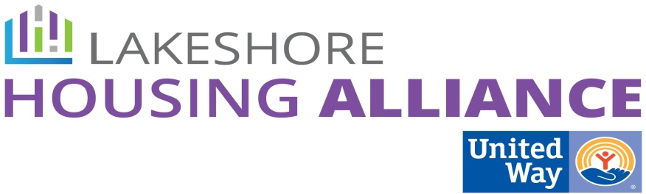****

**Private/Non-Profit Partnerships Work Group**

Tuesday, March 29, 2016, 2:30 – 4:00

Center for Women in Transition

411 Butternut, Holland

**Present**: Holly Johnson, Beth Hanis, Jane Johnson, Anna Bednarek, Marge DeBlaay, Patrick Moran, Liz DeLaLuz, Chris Bennett, Sonya Archer

**Minutes**

1. Welcome and Introductions
2. Review Progress

Patrick reviewed progress to date of all work groups including GIS map, Land Bank authority details (see attached), housing developments, etc. Patrick also discussed the direction of Ottawa Housing Next as an entity that gathers resources, educates the community and encourages action. There was follow-up discussion about details of the Land Bank.

**Feedback**:

* Take existing assets and combine them in a creative way to make something new.
* Important to measure the success of OHN not by tangible outputs but what has been facilitated in the county. Data and coordination is expensive and needed and takes a long time.

1. Employer/Community Assisted Housing

* Ideal Mixed Income Community
* Housing Support as Employee Benefit

1. Business Leader Education

* HR Survey

Patrick reviewed the draft survey and these changes should be made:

* + Gift card incentive of $50 (Meijer for example) and ask/encourage individual companies to add extra.
  + #3 – Do you feel your housing is affordable?
  + #5 – Does the distance… add “of your home” …
  + #7 – How many people live in your house? ____Adults ____Children
  + Don’t forget to add the demographic questions.
  + N = at least 1300 responses
  + Tell them about resources if in housing crisis
  + Name, contact info, for a forum
* Parameters – UW companies

1. Landlord/Tenant Barrier Removal

* Case Management “Hub” and Property Management “Hub”
  + Community Action House and Good Samaritan Ministries are interested in expanding these services respectively but this is a capacity issue for Good Sam and Community Action House?
  + Housing Case Management work group is working on standardizing the case management delivery through best practices.
  + Need to consider other parts of the county; relationships are important.
  + What is the next step for this sub-committee?
    - Coordinate the already existing resources, Love Incs for example
    - *This should be passed on to the Case Management Work Group*
* Landlord Survey
  + Spell out definition of ALICE (Asset-Limited, …) in first paragraph
  + Break out areas by town instead of quadrant
  + #1 – How many rental units do you own/operate?
    - Size information can be obtained from cities
  + #4 – Expand list by adding
    - Education and Rent Assistance Programs
    - Property Damage Fund
    - Guaranteed Security Deposit
    - Utility Assistance
    - Landlord Education
    - Other
  + #5 – Delete
  + Add optional name contact information if you’d like more information regarding this survey or training. It should be stated that the survey is otherwise anonymous.
  + What else would you like to share with Ottawa Housing Next about renting to low income households?
  + N = TBD but maybe 10%of landlords
  + $100 gift card incentive - Home Depot, DeLeeuw, etc…

1. Next Steps

* Finalize and conduct both HR and Landlord Survey
* Coordinating the separate parts. How does this happen? Begin to have conversations with the agencies eastside of county.

1. Next Meeting:

Community Conversation, April 19, Boatwerks Event Center, 7:45-11:00