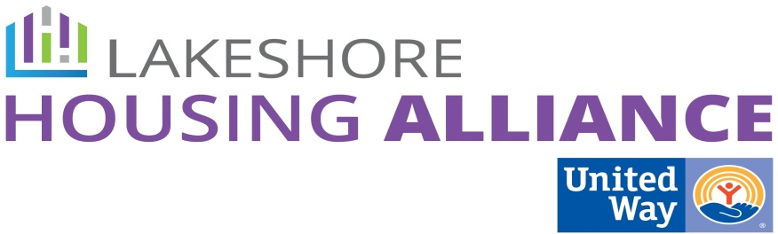****

**Private/Non-Profit Partnership**

Landlord/Tenant Barrier Removal Project

February 26, 2016

Minutes

Present: Anna, Ashley, Jane, Liz, Lyn, Patrick

1. **Concept Review**

Patrick reviewed the Ottawa Housing Next process.

1. **Review Survey Results**

* A survey was conducted with housing agencies regarding the barriers facing tenants and landlords to answer the question “who already addresses the barriers?” Which agencies affect the barriers?
* What do we want to do with the tenant barriers?
  + Do we persuade people to fill the gaps?
  + One agency dedicated to landlords and tenants to make it comprehensive.
  + Expand HARA – give them more resources to address the zeroes and ones.
  + Just because we work on it, how successful are you?
  + Options
    - All addressed by new program
    - Persuade existing programs to expand
    - Issue by issue
  + Rank

**HIGHER**

Stock

Voucher/Cost

Negative Background Check / HSA / Qualifications

Impact

Deposits

Pets

**LOWER**

* + Brainstorming
    - Expand HARA to be a “1-stop hub” or I & R agency: Case Management Hub
    - Expand current agencies
* What do you want to do with landlord barriers?
  + Already doing much more on the tenant barrier side. Why is so little being done on the landlord side?
  + Rank

**HIGHER**

Money

Stigma/Experience

Impact

Too many applicants

**LOWER**

1. **Next Steps**

* Ask HARA and other agencies that provide case management, “How could you do more? With more resources:
  + To increase your service population to include the ALICE population. Include a warm hand-off to existing case management organization.
* Survey landlords
  + What would you need to rent to the ALICE population?
  + What would you be willing to change in order to rent to ALICE population?
  + Rank the barriers