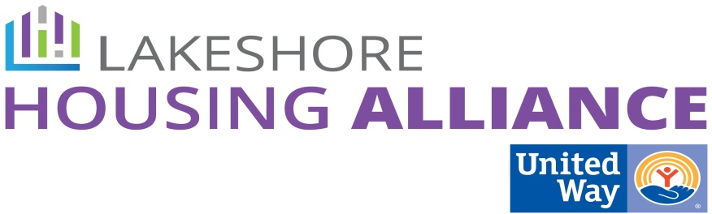****

**Inclusionary Zoning**

**July 2, 2015**

**Fillmore Complex**

Present: Lyn Raymond, Patrick Moran, Keith VanBeek, Steve Bulthuis, Josh Owens, Jerry Alkema, Albert Doorn, Joel Dye

Minutes

1. **Welcome and Introductions**

Keith welcomed the group and facilitated introductions.

2. **What is Collective Impact?**

Patrick reviewed the process thus far.

3. **Work Group Expectations**

Patrick reviewed today’s expectations and the on-going work group expectations. Patrick presented the flexible framework: 6 meetings over the course of the next 12 months, 2 to prioritize needs, 2 to identify projects, 2 to create an action plan for implementation. Each work group will move at its own pace.

4. **Review input from March 20th Community Conversation**

* Patrick facilitated a conversation about a few of the strategies generated at the March 20th meeting. by asking the questions which of these strategies will work to increase affordable housing in our community. Pros and Cons
  + Map current affordable zoning.
    - What does it mean to map current affordable zoning?
    - Zoning Enabling Act requires a Master Plan updated every five years which would include current zoning and what you picture will happen in the future.
    - How do you overlay that with what is affordable to an ALICE household? GIS concept makes a lot of sense to identify those areas. A zoning map already exists.
    - Use correct language – affordable zoning doesn’t exist.
    - What will the map include?
      * Zoning
      * Transportation – public transportation, commute time, non-motorized connectivity (walking, biking)
      * Income – Census earnings
      * Property value (State Equalized Value x2)
      * Job centers (where ALICE works)
    - Zoning isn’t tied to land value.
    - What kind of zoning encourages affordable housing?
      * Smaller square footage.
      * Higher density.
      * Accessory dwelling fees.
      * Mixed use
    - Housing in Ottawa County doesn’t expand the supply so that it expands social integration, instead of the opposite.\

**Needs clarification**

* + - How do we take demand into consideration?
    - Consider changing requirement of other components such as water, curbing, etc. which would add cost (or value) to the development.
    - We will need to be more specific about the unmet need.
    - Collect the Master Plan philosophies from each municipality.
  + Create mixed income developments
    - We need a higher understanding of what the global problem is that is negatively impacting the community. Good data is necessary to make better choices in the future.
    - Political will is required.
      * Townships do not create/fund developments. Big issue is not political will but who will fund the development. Perhaps it would be a “benevolent group.”
    - Zoning can solve a stock and cost problem.

**Needs clarification:** Zoning doesn’t create or deplete housing stock.

* + - We would have to change some current zoning to include mixed use. We can change the law to include it.
      * Allendale allows mixed use. Mixed use is not common because the developer is buying expensive commercial/industrial land for low return residential. **Since zoning already exists are we looking at the real issue of economics?**
    - Yes, you can add ALICE level housing to current higher income zoned areas but it decreases profits for a developer and landowners.
    - It is simply a square-footage issue for zoning.

**Needs clarification**: Most communities allow low square footage in their zoning. Can you build two bdrms, one bath in less square feet? If it is allowed in zoning why are we identifying this as a zoning issue

* + - How is the tool used? Is it exclusionary or inclusionary?
    - Across all of Ottawa County, can we remove roadblocks to promote/allow flexibility in zoning and its requirements to promote housing for ALICE?
    - Density bonuses.
    - Quality of life is important to keep in consideration.
  + Create a regional zoning authority or coordinate zoning.
    - A larger group does zoning for all.
    - Higher level coordination doesn’t fix the core problem, government is still burdened by reflecting the will of the people.
* Rating Scale
  + See attached.
* Who else needs to be involved?

5. **Next Steps**

* **Zoning Map**
  + Who will do it?
  + What layers?
  + Gather layers?
  + Make sure to qualify the outliers (student housing, etc)
* **Create mixed-income developments**
  + Educate the community
  + What are the barriers?
  + Level of analysis of each level of government entity, developers.
    - Ottawa Housing Next approved achieving a larger goal
    - What would it look like to approve?
  + How to develop the support so that political will can stand strong?
  + How can the six workgroups support and create support to the larger plan?

6. **Next Meeting**

* What do we have to do in the background so the work will be valuable at the work group level?