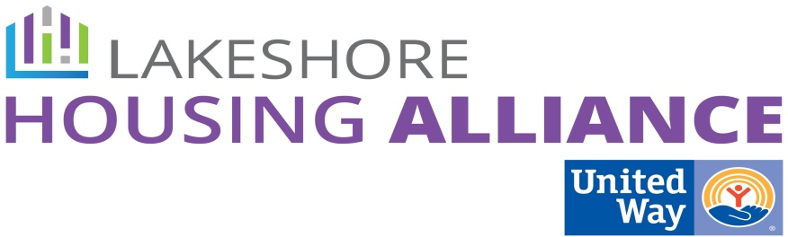****

**Housing Trust Fund**

February 24, 2016

Fillmore Complex

**Present:** Christen, Sue, Gail, Al, Paula, Bree, Kristy, Lyn, Liz, Patrick, Todd, Marge, Kay

Minutes

1. Concept review

Patrick reviewed the concept of Ottawa Housing Next

1. Overview: Michigan Housing Trust Funds

Lyn reviewed the existing HTF’s in Michigan

1. Review October 2015 Minutes

* Patrick reviewed the funding sources chosen by the group at the last meeting.
* Al reviewed each potential funding source identified at the last meeting none of which are potential sources except PUD’s and he wasn’t sure about hotel/motel tax.
* What is a Land Bank:
  + Tax delinquent property fund a tool the state adopted to take control of property then sell it the proceeds going to the Land Bank (Genesee, Wayne, Grand Traverse County etc have been the most successful)
  + Ottawa County established Land Bank in 2007. Not a lot of land with buildings to sell. Small vacant parcels to sell are the most common, properties between existing props.
  + $91,169 currently in the Land Bank and there is not a regular source of revenue. Not very sustainable in Ottawa County.
* Use a private donor as an investor. $150,000 - $50,000 donation, $100,000 as a no-interest loan. Would need a sustainable stream.
* Michigan Housing Trust Fund
* Grants
* Millages: Long term and likely sustainable.
* What about a housing commission?
  + Increased the number of vouchers initially
  + Not sure what else would be a benefit of reinvigorating the housing commission.
  + Still exists and people are still appointed.
  + Can apply for federal funding?
  + Can it be HUD approved?
* All chosen sources need to be in the mix

1. Next Steps

* Paula’s information about the housing commission
* Create a vision with the Private/Non-Profit Partnership
  + Build mixed income communities
  + Acquire in pre-existing communities (parsonages, for example)
* Use Land Bank and Corporate support to create a staffer to push the idea forward.
* Request more technical support from the Center for Community Change
* Presentations from City/County of Kalamazoo and Grand Traverse County.
* Ask land bank to seed work