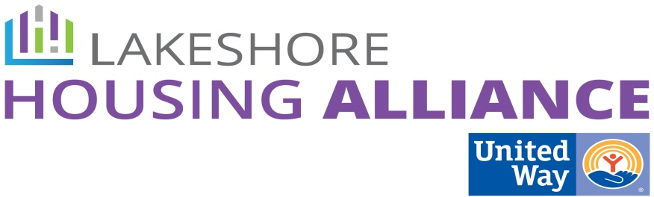****

**Case Management**

August 4, 10:30 AM

Department of Health and Human Services

12185 James St

Holland

**Present**: Jody Immink, Jennifer Boerman, Kendra Spanjer, Lyn Raymond, Jo Ver Beek, Suzanne Visser, Brian Vork, Carrie Benchich, Lindsey Ajega, Holly Seymour, Melanie Weaver, Christen Korstange

Minutes

1. Welcome and Introductions

Patrick reviewed the process thus far.

2. Case Management Best Practices

* What’s missing? (Change or Add)
  + Staff are Prepared and Supported
    - Specifics to each agency in **training and orientation**
    - In training and orientation there is a cost to some bullet points. Can we provide the actual resource?
    - Add Poverty Education in training module
    - Add Personal Safety in orientation and training
    - Add adults to reporting of abuse and neglect
    - Information and Referral sources/Options Counselors
    - **Professional development**
    - Cyclical training
    - How to get approval to offer CEU’s
    - Substance abuse and Criminal Justice system
    - Industry Specific trainings
  + Strength-Based Approach
    - No additions or changes
  + How to Identify and Locate Local Resources
    - **Case Managers Identify Resources**
      * Consider changing “require” to “encourage.”
      * Replace “volunteerism” with “Persuade more agencies to offer tours and informational meetings.”
    - **Notify and Update Service Providers**
      * How to best update information - centralize that process.
      * Choices are great for dinner not so much for Information and Referral.
  + Working to Reduce Isolation
    - Change “church” to “social” group but use the word “faith-based”.
    - 12 Step, Support Groups, Sports, Play Group
    - Identify and Address Barriers
      * to engagement like transportation, financial stability, lack of child care, move safe neighborhoods here, legal
    - Identify Family Support
  + Self-Care (Jenn)
    - Burn-out reduction strategies
  + Case for Case Management Best Practices (Holly)
    - Reduces turnover, increases quality
* Delivery models
  + In conjunction with Community Resource Fair/other event.
  + On-going support arena like
    - learning circles,
    - lunch and learns
    - Quarterly Breakfasts with both directed learning and guided discovery.
  + Full training/In-service with experts
  + “On Your Own” training module
    - Webinar
    - Online
    - Paper
  + Capture the “stuff” you do in the above delivery in a Best Practice model.

6. Next Steps

* How do you see this becoming reality?
  + Throw it back to the Lakeshore Housing Alliance
  + Contact the Lakeshore Non-Profit Association to address it as system issue.
  + Working with existing training opportunities
* What do we do next?
  + Coordination of Case Management
    - How do we adjust the current system to move up the continuum of case management efficiency and effectiveness?
    - What are the barriers to efficiency and effectiveness?
    - What words define efficient and effective?
  + Centralized Intake

7. Meeting Schedule

Meeting Wizard – avoid Tuesdays