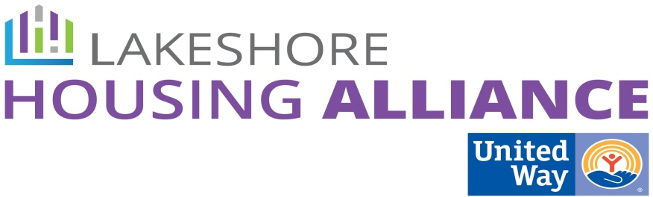****

**Case Management**

June 4, 2:30 PM

Department of Health and Human Services

12185 James St

Macatawa Room

Holland

Minutes

Melanie Weaver, Christen Korstange, Kendra Spanjer, Brian Vork, Patrick Moran, Lyn Raymond, Liz DeLaLuz, Chris Hoflund, Jo VerBeek

1. Welcome and Introductions

Kendra welcomed the group and facilitated introductions.

2. What is Collective Impact?

Lyn and Patrick reviewed the process to date.

3. Work Group Expectations

* Liz presented the flexible framework: 6 meetings over the course of the next 12 months, 2 to prioritize needs, 2 to identify projects, 2 to create an action plan for implementation. Each work group will move at its own pace.

4. Review input from March 20th Community Conversation

* Patrick facilitated a conversation about a few of the strategies generated at the March 20th meeting by asking the questions *which of these strategies will work to increase affordable housing in our community?*
* Educate
  + Confirmed that education about resources is necessary.
  + Staff need a better system.
  + No consistency of information about resources.
  + Eligibility guidelines are confusing for clients.
  + Do we need to do a better job with 211 and WFC or do we need to create something else?
    - Database for housing availability.
    - One Housing Authority
    - Case management should be about the persons needs or about particular issues.
    - Hone in five or six big issues.
* Centralized intake
  + Concerns about confidentiality, capacity, and volunteer skills.
  + Must be willing to work together to make it work.
  + Build an infrastructure now to address future needs.
  + Remember it needs to address the whole person
* Create and share best practices

5. Who else needs to be involved?

* + Good Samaritan Ministries
  + Grand Haven Salvation Army
  + The People Center
  + Center for Women in Transition
  + HHI
  + Disability Network

6. Next Steps

* Lyn will invite representatives from the organizations listed in agenda item 5.
* Begin with “create and share best practices.”

7. Meeting Schedule

* Lyn will send out a Meeting Wizard for a date within the month.