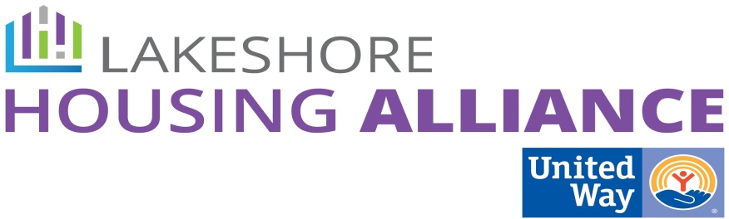****

**Private/Non-Profit Partnership**

**Employer Assisted Housing**

**February 16, 2016**

**United Way**

**Minutes**

**Present:** Linda Jacobs, Scott Sterenberg, Allison VanderPloeg, Joel Westmaas, Liz DeLaLuz, Amy Alderink, Lyn Raymond, Patrick Moran.

1. Introductions
2. Concept review

Patrick reviewed the progress of Ottawa Housing Next.

1. Details

Let’s create as many details of a development project so that we have a template when property and partners become available.

* How do we get to mixed income?
  + What are the income targets?
  + Does the development subsidize the lower rent?
  + Is there rental *and* ownership?
    - Creating mixed income through acquisition. Find out where the 35% is needed and build/convert them *there*.
      * Convert substandard property to affordable rental
      * In-fill is simpler than greenfield development
      * Exclusionary zoning make this type of conversion difficult.
    - New Development:
      * Whole Community: 75% Rent 25% Owned
      * Rental: 35% Market 65% Subsidized
      * Allow people to move up the housing ladder
* If we were building 20 units, what would we build?
  + 15 rented, 5 owned, 10 of those subsidized, 5 market, 5 owned
  + What does the data tell us about size of units? **What kinds of units are in most demand?**
  + Definitely a need for smaller units (studios and 1 BR).
  + Young families (One parent families) may have a need for more supportive services
* How are we layering services?
  + Community Center
    - Information provided regularly
  + Green Space
  + Bus Stop/Shelter
  + Circles: Bringing people together of different income levels
  + EPIC Program: How do you get ready for change?
  + Playground, Soccer field, Basketball Court
  + Create community and a desire to engage with the community. Supportive services are not part of the “program.”
  + Could have a Community Connector or recruit someone in the community to play that role.
  + Give Back Programs
  + Co-Housing or Co-op Housing
* What is the perfect mix of funding?
  + How do we choose who develops the property?
  + Where does the money come from for conversion?
    - Brownfield
    - Neighborhood Enterprise Zone – the City creates the zone and freezes the taxable value.
    - Solicit current landlords/owners
    - Fundraising
    - Gap financing from the State
    - Homecor: 0 Interest loans from private investors.
      * $100,000 loan with a $50,000 donation over 5 years ($10,000 per year)
* Let’s continue to talk about **scale.**
* Who decides?
  + Chairs of the work groups
* Who owns?

1. Next Steps