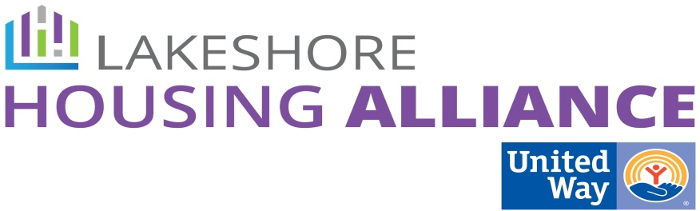****

**Private/Non-Profit Partnership**

**Employer Assisted Housing**

September 30, 2015

12:00 PM

United Way

**Present:**

Patrick Moran, United Way Nate Schipper, Third Reformed

Linda Jacobs, Good Samaritan Ministries Denise Nestel, IPC

Amanda Telgenhof, United Way Joel Westmaas, Taking Root Ministries

Amy Alderink, Home Corps Allison Vander Ploeg, Lakeshore Habitat for Humanity

1. Patrick opened with introductions
2. Concept review
   1. Review of OHN and private-nonprofit partnerships
   2. Review of ALICE and Affordability Index
   3. Review of draft concept (See attached)
      1. GIS map
      2. Four corners of sustainability – pathway partners, funding partners, renovation/maintenance partners, and employer partners
      3. D we like finding and acquiring properties, or building a neighborhood, or both?
         1. Neighborhood should be mixed income
            1. Wouldn’t want a dense low income population in one spot
         2. Where are the developers in this? How can we incentivize?
         3. Regardless of scattered sites or a housing complex, it should be mixed income
      4. This will work, because it’s worked other places
      5. Review of concept budget
         1. Overall thought is that we have to change the landlord
            1. Developers make a profit as an outcome; our outcome is the housing, not the profit
            2. Changing the business model
            3. Need to show employers that housing is a problem for them
3. Possible parameters for selecting companies:
   1. ERN company or something similar
   2. HR/corporate structure for housing assistance, benefits, staff support
   3. Is it for people who live in Ottawa or *so* people can live in Ottawa?
   4. ALICE pay structure (and how many)
   5. Offers pathways for employees
   6. Upward mobility
   7. Look at national corporations (Walmart, etc.)
   8. What is larger? 50/100 or do we base it on sales
   9. Money has to be spent in Ottawa
   10. Look into turnover (what is high)
   11. Deep roots in community / sustainable company
   12. Well respected, good reputation
   13. School location (proximity) and performance
   14. Community infrastructure
4. UW, New Entity, or Old but New
   1. Hybrid model - UW fiduciary, with another nonprofit to oversee
   2. Minnesota employer assisted housing as reference
   3. Umbrella helps ID local opportunities - Dirt is local, need to know where it is and how to acquire
5. Action Steps:
   1. Find someone to notify of properties that are bank owned or that have elderly occupants
   2. Ask LHRM
   3. Find data on “imported” staff / What percentage live where?
   4. Ask L.A. or MI Works! For wage and occupation projections by industry and sector