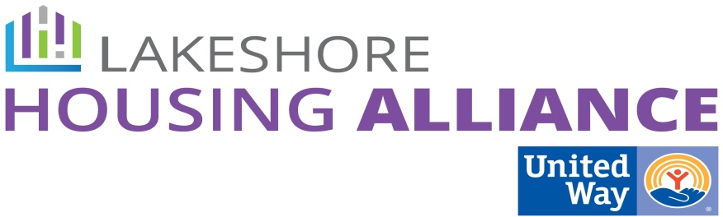****

**Private/Non-Profit Partnership**

**Business Leader Education Project**

**February 19, 2016**

**Present:**  Liz DeLaLuz, Rick Mannes, David Gignac, Sonya Archer, Lyn Raymond, Patrick Moran

**Minutes**

1. Concept review

Patrick reviewed the process so far.

1. Parking Lot from 9/2015

* HR Survey
  + Hypothesis: Does housing instability effect recruitment, retention, and attendance/productivity of employees?
    - **Questions:**
    - **Company demographics:**
      * What is your retention rate?
      * Is retention an issue?
    - What is your family size?
    - Does the distance from work present a problem in getting to work?
    - Have you ever experienced trouble finding appropriate housing near work?
    - Would you like to live closer to work?
    - What gets in the way of living near work?
    - How long is your commute?
    - How close to work do you live?
    - Is your housing affordable?
    - Are you happy with your housing?
    - How long have you worked at this company?
    - Was housing a consideration when accepting your current job?
    - Do any of these things get in the way of your work attendance?
      * Child care?
      * Transportation?
* Logistics
  + Electronic and Paper Survey
  + Endorsers will be important to encourage buy-in
    - Lakeshore Advantage
    - Chambers
    - LHRMA
  + Finite study – what is the target number?

1. Housing Support as Employee Benefit

* What kinds of support? What will it pay for?
  + Transportation assistance – company bus or individual trans. support
  + Housing Voucher
  + Housing Match
  + Down Payment/Rent Assistance
  + Walk to Work/Bike to Work (Rack of bikes)/Wellness Support
  + Internal Social Supports
  + Mentoring
  + Increase capacity of Employee Assistance Program + resources
  + Bonus package/housing Incentive package – “We’ll pay your December rent if you have perfect attendance.”
  + “Shares” in a housing development
* Who pays for it? And how do we sell it? How is it a win – win?
  + Possible partners
    - OHN Work Groups
    - Faith Community
    - Government
    - Non-Profits (realignment?)
* Who will be eligible?
* How would funding be disbursed?

1. Next Steps
   * Report to group on company visits
   * Finalize HR Survey language
     + Distribute to committee