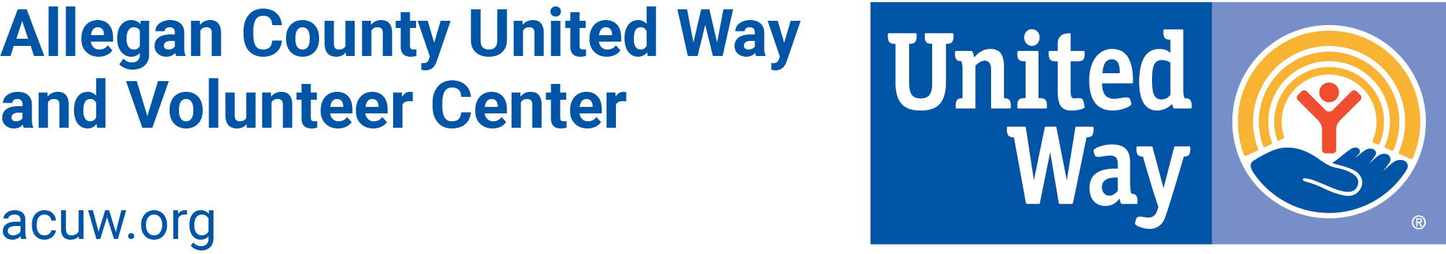

Little Free Library Steward Agreement
Thank you for your commitment to hosting a United Way Little Free Library and supporting literacy in Allegan County! Please read the following requirements and sign below.
As a steward of a United Way Little Free Library (LFL), you agree to:
- Keep LFL clean and free of debris
- Monitor book quantities
- Ensure that LFL flyer remains intact and on display within the unit
- Notify United Way with updated contact information, should the LFL contact person for your organization change
- Notify United Way if/when your LFL:
  - Needs more books
  - Needs repairs or re-painting
  - Needs replacement (if LFL is broken or rusted out)
  - Needs removal
Please contact Kessie at 269.673.6545 or kkarg@acuw.org with questions or if any of these items need to be addressed. United Way will also contact you periodically to check on the condition and status of your LFL.
Name: _____________________________________________________________
Address: ___________________________________________________________
Organization: _______________________________________________________
Phone and email: ____________________________________________________
Signature: _________________________________________ Date: ___________
Thank you for hosting a Little Free Library!

