August 10, 2018

Beth Larsen
Center for Women in Transition
411 Butternut
Holland, MI 49424

Dear Beth,

On behalf of the Lakeshore Housing Alliance, I am pleased to inform you that the following projects have been reviewed and approved by the Allocation and Accountability Committee. The projects will be ranked on the Priority Listing (see enclosed).

Renewal
Rapid Re-Housing for Victims of Domestic Violence
Grant # MI0494L5F191702
Approved Amount: $111,064

DV Bonus
Rapid Re – Housing
Approved Amount: $53,617

As per HUD regulations, Project Applications must be submitted to eSNAPS no later than 30 days prior to the CoC Collaborative Application submission. Please submit your project applications on e-SNAPS no later than end of business Monday, August 18.

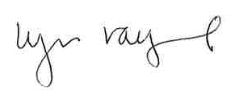

Lyn Raymond
Director
Lakeshore Housing Alliance

